Image Processing In Stroke Classification
NaveenKumar K
Anand Kumar
Guru Aswath
Cross-sectional imaging approaches expect a key part in assessing depleting mind wounds. Experts regularly choose depleting size and reality in CT and MRI. Separating and recognizing relics is basic in dealing with clinical pictures. Picture and sign taking care of are used to describe tissues inside pictures solidly associated with edges. In CT pictures, a close to home cycle takes a stroke ’s manual structure with less precision. This segment presents the utilization of both picture and sign taking care of strategies in the depiction of Brain Stroke field. This part moreover summarizes how to depict the brain stroke using different picture dealing with computations, for instance, ROI based division and watershed procedures.

Introduction
An ailment called a stroke is cell passing related with frail blood stream into the cerebrum. It is an ischemic stroke brought about by madness brought about by blood stream, and it is a draining that in two unique structures causes hemorrhagic stroke.
The World Health Organization has shown that it is known as a neurological weakness by cerebral vascular part as a stroke during the 1970s. One of the most generally perceived kinds of stroke is ischemia which makes a lack of brain capacities due outrageous shortfall of blood supply. Issues that can emerge, in the event that an e-cigarette isn’t utilized as expected, incorporate bladder disorder and bladder brokenness. Hypertension of the veins is the main gamble factor on stroke. End is all around picked the clinical evaluation and is helped by clinical imaging, for example, CT or MRI checks . CT ranges could discourage dying, yet ischemia, which in general doesn’t show up OK off the bat in the CT channel, may not absolutely be confined .
PC with sensible programming can use to change and custom a modernized picture evaluation. A PC can convey your own changed electronic picture. Obvious level picture making due, as opposed to chief sign making due, appreciates many advantages. The new programming has credits that grant one to be more flexible with plainly, sound and text yield features. Since modernized picture overseeing can be shown in a different way, electronic pictures can be portrayed as (something like two) layered. The Nobel Prize is acquir ed by this sort of examination in 1979. During the 1990s, clinical picture dealing with headways were utilized to control beats during coronary course keep away from combines.

Figure And Tables

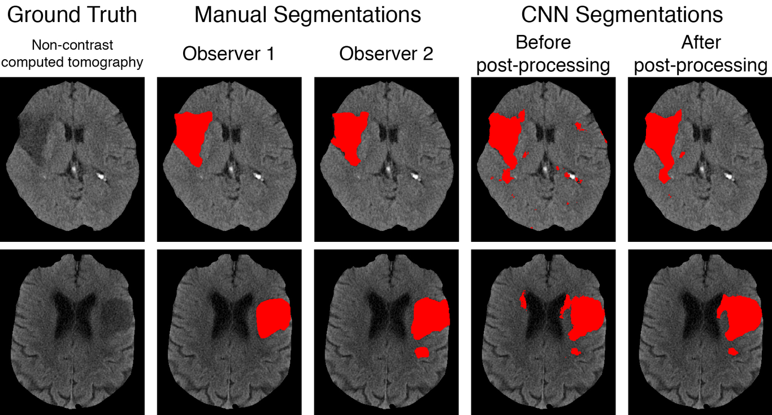
Sample Stroke Figures
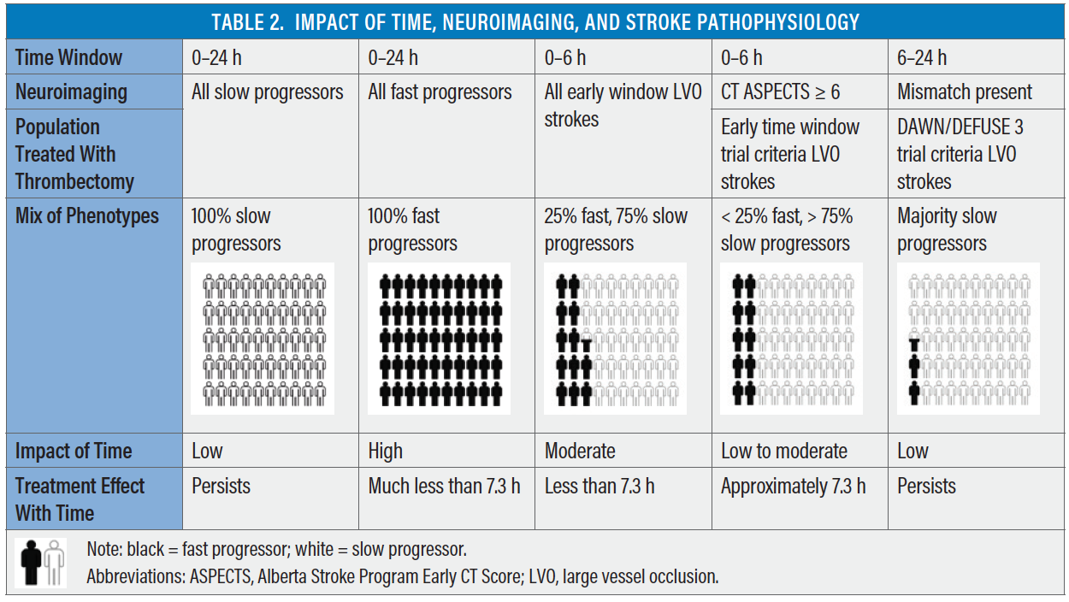
Impact Of Time , Neuroimaging, And Stroke Pathophysiology

Stroke Classification
Strokes can be mentioned into two fundamental sorts: ischaemic (for example accomplished by a coagulation in a vein in the cerebrum), or haemorrhagic (for example accomplished by a direct in the mind). These two key depictions permit further assembling into subtypes.
STROKE
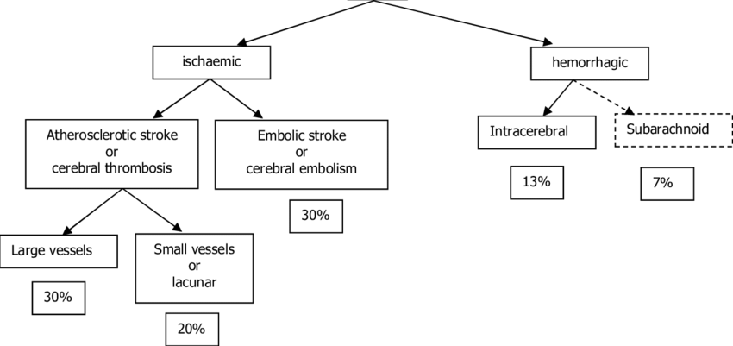
Classification Of Stroke

Ischaemic Stroke
A structure for categorisation of ischaemic stroke subtypes, transcendently established on etiology and the framework, provoking the vessel hindrance, was created for Trial of Org 10172 in Acute Stroke Treatment (TOAST). This information is huge in ordinary organization, as it should affect both the extraordinary and helper expectation strategies.
The TOAST portrayal is the most by and large used and integrates:
1. Tremendous vessel atherothrombosis;
2. Cardio embolism;
3. Little vessel sickness;
4. Other chose causes;
5. Uncertain causes.
The questionable causes also consolidate cases including more than one fundamental part. Gigantic vessel atherothrombosis implies the improvement of lipid-stacked atherosclerotic plaques on the internal mass of a colossal vessel and can impact both extracranial and intracranial halls. The most generally perceived objections for plan of atherosclerotic plaques consolidate where the typical carotid conductors split, the start of the vertebral veins and the course of the middle cerebral inventory course. In atheroembolism, a blood coagulation structures on the mass of a vein, self-destructs and sheds pieces of bunch, which are conveyed downstream and hold up in more humble vein branches, achieving various more unobtrusive strokes an inside the typical region of the parent vessel.
Cardioembolism happens due to blood bunches, which could have formed inside the heart, relaxing, entering the stream and a while later becoming held up downstream in a cerebral channel. Bunches can approach inside the heart due to intracardiac equilibrium of blood (for instance atrial fibrillation) or due to adhering to a thrombogenic contraption or sore (for instance an implanted prosthetic valve).
Little vessel disease suggests occlusive ailment including the microcirculation of the frontal cortex. Typical regions for little vessel disease consolidate significant area of the hemispheric white matter; the district of white matter known as the internal compartment, near the proximal focus cerebral passageway and gave blood by its entering branches; the pons in the mid-brainstem, given by penetrators arising out of the basilar vein; and the thalamus, subordinate fundamentally on pieces of the back cerebral courses. Areas of limited corruption in these regions are nearly nothing (<1.5cm) and dependent upon the region inside the frontal cortex, commonly produce one of the model lacunar messes:
1. Pure motor secondary effects (for the most part face and arm, or arm and leg, including 33-half of by and large little vessel strokes);
2. Pure unmistakable;
3. Mixed sensorimotor;
4. Ataxic hemiparesis (inadequacy of one side with unbalanced ungainliness [ataxia] of a comparative side);
5. Gawky hand dysarthria, awkwardness of either hand, which is screwed up concerning any weakness of the extremity, got together with slurred talk.
Other concluded causes integrate strokes achieved by extracranial vein investigations, non-atheroscleotic vasculopathies, hypercoagulable states or haematologic wrecks.
Uncertain causes recall patients for whom an all out screening workup for cardiovascular conduction or essential inconsistencies, intracranial or extracranial gigantic course stenosis, coagulopathy, and various conditions uncover no causes. Around 40% of ischaemic strokes are of uncertain cause. The stroke may be seen as cryptogenic after standard assessments when clinical evaluation and neuroimaging suggest a shallow or tremendous, significant cerebral infarct, but nothing based on what was simply referenced routine vessel-imaging, heart or haematologic tests have uncovered a sensible defense of the stroke. Cryptogenic embolism has actually been given the term Embolic Stroke of Unknown Source (ESUS).

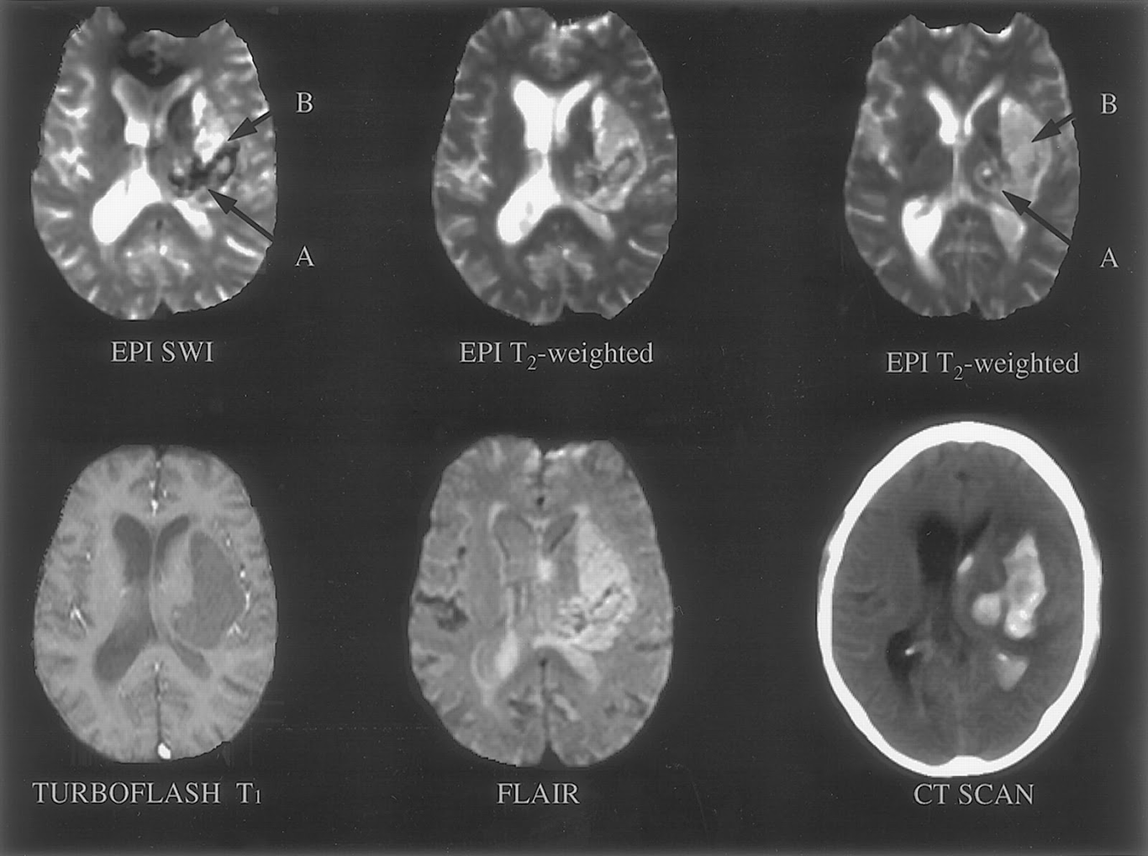

Risk Factors
Risk factors for stroke are named modifiable or non-modifiable. Regular modifiable bet factors that are not such a great deal of unambiguous yet rather more common combine hypertension, diabetes and smoking, which all effect thriving in extra ways than one and permit huge chances to change risk in tremendous measures of individuals. Other express wagered factors that are more surprising solidify atrial fibrillation and TIAs. Non-modifiable bet factors solidify age (stroke endanger copying with predictably of life after the age of 55 years), course (a greater number of men have strokes than ladies; in any case, more ladies pass on from strokes) and hereditary parts (for example Fabry’s problem)

Haemorrhagic Stroke
The fundamental pathology of haemorrhagic stroke is an area of depleting that directly makes hurt the frontal cortex tissue. 33% of patients giving ICH will, inside the underlying very few hours, have in no time expanding haematomas. This, alongside age and neurological deficiency, is farsighted of awful outcome at 90 days.
The spilling blood achieves the expulsion and strain of adjoining tissue, which in the end dismantles into ventricles and subarachnoid space. Patients may similarly give additional symptoms of serious headache (as a result of extended intracranial pressure or meningeal unsettling influence), lower Glasgow Coma Scale (GCS), hurling, neck solidness and obviousness.
Hypertension is the most exceptional modifiable bet factor for ICH. A basic degree of hypertensive hemorrhages occur due to non-adherence of antihypertensive medication, which can be intentional or unforeseen, or in light of unlawful catecholaminergic drug use (for instance cocaine or methamphetamine)

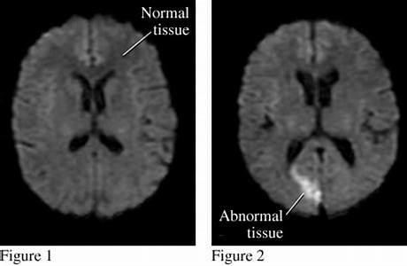

Haemorrhagic Conversion Of Ischaemic Stroke
This could occur after thrombolytic drugs (alteplase) are coordinated to patients with an ischaemic stroke or where a patient has a tremendous cerebral bunch, which will in everyday be more typical with cardioembolic strokes. The major troublesome effect of thrombolysis is interesting intracerebral release, saw in around 6-7% of cases. The bet of intriguing ICH increases with age, hypertension, incredibly troublesome neurological lacks, outrageous hyperglycaemia, and maybe, with early ischaemic changes on handled tomography (CT) checks.

Medical Imaging
Clinical picture overseeing in clinical idea and biomedical investigation places appreciates showed overpowering advantages to the world . Of late, a lot of assessment articles were scattered, featuring the fundamental for Medical picture overseeing in various clinical issues of the human body and its significant inside organs. The point of convergence of intelligent imaging evaluations is to work with the most by and large saw method for managing seeing a patient’s body and its major inside organs with higher capacity and accuracy in demand disorders or wounds . Regularly, charming reports of patients coordinate radiographic depiction of human body or its parts; utilization of various clinical picture managing approaches further develops the system applied to the patients. Estimations expects a fundamental part in the knick-knacks isolating, division, incorporate extraction and portrayal, which will accelerate the contamination finding. In the new twenty years, basic learning computations recognized a focal part in the clinical picture managing extra made execution than the standard Man-made awareness estimations, such enormous level evaluations that show more clear accuracy in the portrayal of disease cells, wounds, organ division and clinical picture improvement with a run of the mill precision levels of 96% to 98% . In the fundamental future, certain level computational and learning moves close like Deep learning and mix colossal learning approaches will expect a fundamental part in the field of charming imaging with most fundamental clinical impact on clinical imaging assessments to give besides settled on decision help with clinical picture understanding and assessment.

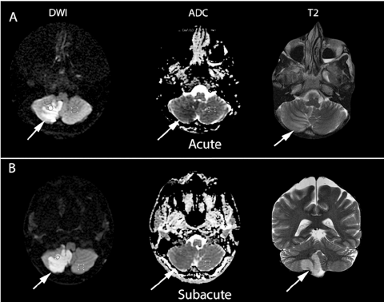

Medical Image Algorithm

Region-Based Methods :
A locale is verified pixels which two by two
are neighbours and the cut off is created utilizing contrasts between two districts. By far most of the image division procedures rely upon region and cut off properties. Here we figure out two most popular region based approaches: thresholding and region creating.

Thresholding
Thresholding is one of the most straightforward and fastest division methodologies considering the assumption that pictures are formed from regions with different dim levels. The histogram of pictures has different zeniths likewise, valleys which can isolate pictures into different parts . Limit is a value in a histogram that isolates powers into two areas: the underlying fragment is the “closer view” having pixels with abilities more unmistakable than or identical to the edge and the ensuing part is the “establishment” having pixels with abilities less than the breaking point . Along these lines,
where f(x, y) is the pixel power in the (x, y) position
additionally, T is the cut off regard. An inappropriate cut off regard prompts sad division results .
To detach more than one article with different faint levels, more than one edge is used which is called multi thresholding. For this present circumstance, thresholding is applied in the CT image of legs to eliminate the bone area from the establishment.
Thresholding division for the most part doesn’t take into account the spatial information of pictures which leads to antipathy for racket and power in homogeneities. These issues might happen in MRI pictures which fundamentally annihilate the histogram and make partitioning more mind boggling . Worldwide thresholding chips away at the possibility that a picture has a bimodal histogram and the item can be separated from the foundation utilizing a limit esteem. In the accompanying, nearby (versatile) thresholding that utilizes a nearby limit esteem and Otsu’s thresholding that utilizes a programmed edge esteem are depicted.

Local Thresholding
Local thresholding doesn’t give palatable results for some sort of pictures like pictures which try not to have a consistent foundation and have variety across the item. For this sort of pictures, thresholding gives a decent outcome in one district however bombs in other portions of pictures . To find different edge values for various pieces of pictures, the nearby thresholding strategy separates pictures into sub images and afterward ascertains the limit an incentive for each part. The aftereffects of thresholding for each piece of a picture are then combined. In this strategy, a picture is separated into vertical and even lines, while each part incorporates a locale of both the foundation and the article. At last, an insertion is expected to create proper outcomes. Different factual techniques are utilized to choose the limit an incentive for each sub image, for instance, mean, standard deviation, mean and standard deviation together, and mean of most extreme and least. Nearby thresholding needs additional opportunity to section an picture contrasted with worldwide thresholding. This strategy is more helpful on account of pictures with differing foundations.

Otsu’s Thresholding
Threshold value is usually selected visually which leads to problems and may even lead to poor results. To robotize the determination of limit esteem, some strategies have been introduced like Otsu’s technique. The objective of Otsu’s thresholding is to see as an ideal an incentive for worldwide thresholding. In this technique, it is expected that a picture has two pixel classes or has a bio modal histogram . It picks the limit to limit the intra-class change (the fluctuation inside the class) of highly contrasting bunch pixels. The intra-class change could be characterize utilizing weighted condition of changes of each group.

$σ_{w}^{2}\left(t\right)=q_{1}\left(t\right)σ_{1 }^{2}\left(t\right)+q_{2}\left(t\right)σ_{2}^{2}\left(t\right)$ —–>1
$q_{1}\left(t\right)=\sum_{i=1}^{t}{P}\left(i\right)$ ——>2
$q_{2}\left(t\right)=\sum_{i=t+1}^{I}{P}\left(i\right)$ —–>3
$μ_{1}\left(t\right)=\sum_{i=1}^{t}{\frac{iP\left(i\right)}{q_{1}\left(t\right)}}$ —–>4
$μ_{2}\left(t\right)=\sum_{it+1}^{I}{\frac{iP\left(i\right)}{q_{2\left(t\right)}}}$ —–>5
$σ_{1}^{2}\left(t\right)=\sum_{i=1}^{t}{{\left[i−μ_{1}\left(t\right)\right]}^{2}}\frac{P\left(i\right)}{q_{1\left(t\right)}}$ —–>6
$σ_{2}^{2}\left(t\right)=\sum_{i=t+1}^{I}{{\left[i−μ_{2}\left(t\right)\right]}^{2}}\frac{P\left(i\right)}{q_{2}\left(t\right)}$ —–>7
The process can be stopped here and the algorithm continued by applying the within-class variance for all threshold values t and selecting the value that minimizes .To achieve faster calculation, we can use the relation between the within-class and between class variances. Otsu explains that minimizing the intra-class variance is similar to maximizing the between-class variance. After some calculation we have
$σ_{b}^{2}\left(t\right)=σ−σ_{w}^{2}\left(t\right)=q_{1}\left(t\right)q_{2}\left(t\right){\left[μ_{1}\left(t\right)−μ_{2}\left(t\right)\right]}^{2}$ —–>8
The threshold value that maximizes the between-class variance is the optimal threshold value.

Algorithm :
input {seed point}
- Region r = {seed}
- While r. neighbours $≠$ {}
(a) For each voxel x in r . neighbours, if P(x,r) = true, then add x to r
(b) End while
3. Return r
$P\left(x,r\right)=\left|f\left(x\right)−μ_{r}\right|<T$ ——->9

k-Nearest Neighbour
k-nearest-neighbour (k-nn) is a regular non-parametric and commonly used classification method. This method is known as a non-parametric method because the k-nn algorithm does not need any information about statistical properties of pixels. The k-nn algorithm needs a great amount of sample data which are labelled as training data.

Algorithm:
(1) Set labelled training data $X_{D}=\left\{x_{1},...,x_{nd}\right\}$ where $X_{D}∈M_{func}$ .
(2) Choose k neighbours to find.
(3) Choose $d : R^{p}×R^{p}→R^{+}$ any metric (distance measure) on $R^{p}$ .
(4) For any vector $z in R^{p}:$ using $X_{D}=\left\{x_{i}\right\}$
Calculate and sort the distances $d\left(z,x_{i}\right) as \left\{d_{1}≤d^{2}≤⋅⋅⋅≤d_{k}≤d_{k+1}≤⋅⋅⋅≤d_{nD}\right\}$
Compute the label vector
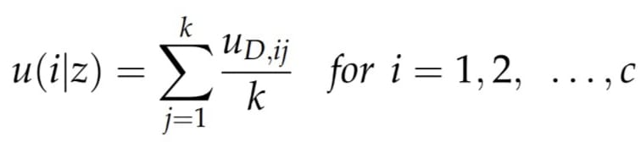
Euclidean distance between two vectors in $R^{p}$ and is declared as follows:
$d\left(z,x_{i}\right)=\left|\left|z,x_{i}\right|\right|=\sqrt{{\left(z,x_{i}\right)}^{T}\left(z,x_{i}\right)}$

Expectation Maximization
The Expectation Maximization (EM) method is an iterative process to calculate maximum-likelihood estimation. This algorithm is one of the most popular unsupervised methods which use density estimation of data pixels. In this algorithm, two steps are run iteratively to achieve the results. The first one is the E step which calculates the expectation of likelihood and the second one is the M step which calculates the maximum-likelihood estimation. The expected likelihood is found in the E step and it will be used in the M step to minimize it. The parameter used in the M step will be a seed for the next E step until it achieves some desirable square errors.
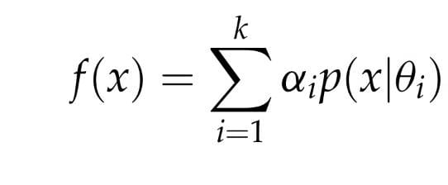

$\sum_{i=1}^{k}{α_{i}}=1$
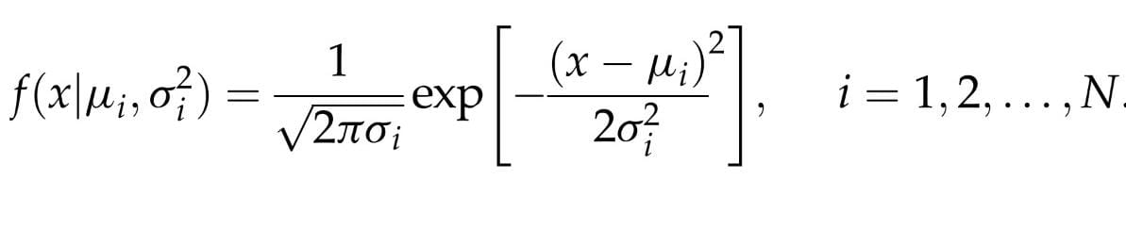

Algorithm:
Evaluation expectancy (E):
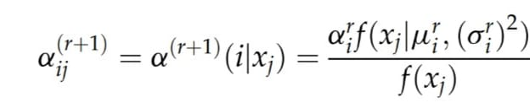
Maximization step (M): Updating parameters of Gaussian Mixture Model (GMM)
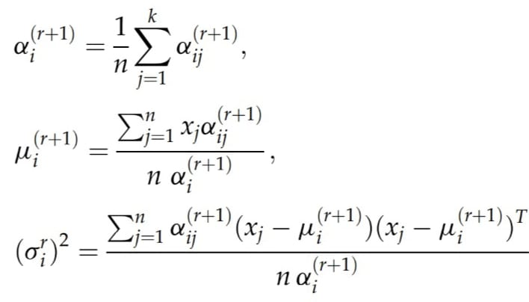
We stop when :
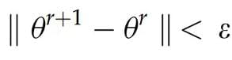

Conclusion
This paper figures out different current picture dealing with systems which are extensively used in clinical picture assessment. The estimations and their applications in clinical picture assessment are presented. Some of them have been applied in MRI pictures, especially for the knee bone. The depiction of each and every system will work with in picking the sensible division procedure.

Acknowledgement

Our deepest thanks to National Heart, Lung, and Blood Institute, India AI.

Reference
1.Ames III, R.L. Wright, M. Kowada, J.M. Thurston, G. Majno Cerebral ischemia. II. The no-reflow phenomenon The American Journal of Pathology.
2.J. Braun, J. Bernarding, H.-C. Koennecke, K.-J. Wolf, T. TolxdorffFeature-based, automated segmentation of cerebral infarct patterns using T2- and diffusionweighted imaging. Computer Methods in Biomechanics and Biomedical Engineering.
3.R.A. Carano, K. Takano, K.G. Helmer, T. Tatlisumak, K. Irie, J.D. Petruccelli, M. Fisher, C.H. SotakDetermination of focal ischemic lesion volume in the rat brain using multispectral analysis. Journal of Magnetic Resonance Imaging.
4. K.A. Dani, R.G.R. Thomas, F.M. Chappell, K. Shuler, K.W. Muir, J.M. WardlawSystematic review of perfusion imaging with computed tomography and magnetic resonance in acute ischemic stroke: heterogeneity of acquisition and postprocessing parameters: a translational medicine research collaboration multicentre acute stroke imaging study.
5. M. Chawla, S. Sharma, J. Sivaswamy, L. KishoreA method for automatic detection and classification of stroke from brain CT images Engineering in Medicine and Biology Society, 2009. EMBC 2009. Annual International Conference of the IEEE.
6. B. Dawant, A. ZijdenbosImage segmentation. Handbook of Medical Imaging.
7. G. Erus, E. Zacharaki, N. Bryan, C. Davatzikos Learning high-dimensional image statistics for abnormality detection on medical images. Computer Vision and Pattern Recognition Workshops (CVPRW), 2010 IEEE Computer Society Conference on.
[1]8. National Heart, Lung, and Blood Institute / Stroke Research.
9. India AI /Stroke Research.
Show all references in article bibliography
- K Zinszer, K Morrison, A Verma, JS Brownstein. Spatial Determinants of Ebola Virus Disease Risk for the West African Epidemic.. PLoS Curr 9 (2017).EditDelete
- Anand Kumar. Image processing in Stroke Classfication. AI in Stroke Research 1 (2022).Edit
- Junmei Zhou, Zhixiong Xue, Ziyun Du, Teri Melese, Paul D. Boyer. Relationship of tightly bound ADP and ATP to control and catalysis by chloroplast ATP synthase. Biochemistry 27, 5129–5135 American Chemical Society (ACS), 1988. LinkEditDelete
- Paul D. Boyer. Energy Life, and ATP (Nobel Lecture). Angewandte Chemie International Edition 37, 2296–2307 Wiley-Blackwell, 1998. LinkEditDelete

Author:

ANANDKUMAR M (AI RESEARCHER / Student)

NAVEENKUMAR K (Jr.AI RESEARCHER / Student)

GURUASWATH CJ (Jr.AI RESEARCHER / Student)

References
A. Kumar, “Image processing in Stroke Classfication”, AI in Stroke Research, vol. 1, 2022.

