Scholarly Article Demo for Literatum Ingest
Alberto Pepe
Ahmad Souqi
Pellentesque tincidunt lobortis orci non venenatis. Cras in justo luctus, pulvinar augue id, suscipit diam. Morbi aliquet fringilla nibh, vel pellentesque dui venenatis eget. Orci varius natoque penatibus et magnis dis parturient montes, nascetur ridiculus mus. Donec ultricies ultrices magna gravida porta. Maecenas accumsan diam dui, auctor ornare ex pellentesque id. Integer tempus massa id augue finibus convallis. Nulla vestibulum, nisl id tempor pulvinar, felis dui pellentesque lacus, quis bibendum metus enim sed ex.

Introduction
Lorem ipsum dolor sit amet, consectetur adipiscing elit (Zinszer et al., 2017). Cras egestas auctor molestie. In hac habitasse platea dictumst. Duis turpis tellus, scelerisque sit amet lectus ut, ultricies cursus enim. Integer fringilla a elit at fringilla. Lorem ipsum dolor sit amet, consectetur adipiscing elit. Nulla congue consequat consectetur. Duis ac mi ultricies, mollis ipsum nec, porta est. ${}_{12}^{4}C_{2}^{5+}$

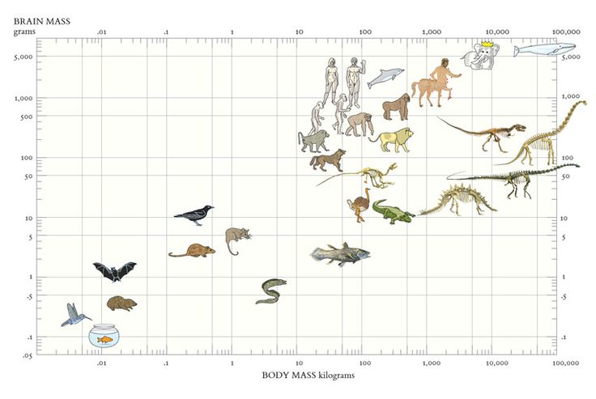
Pellentesque suscipit risus massa, non vestivbulum libero euismod feugiat. In hac habitasse platea dictumst. Maecenas rutrum lobortis lobortis. Vestibulum convallis porttitor sem ac ultricies.

Subsection
Pellentesque suscipit risus massa, non vestibulum libero euismod feugiat. In hac habitasse platea dictumst. Maecenas rutrum lobortis lobortis. Vestibulum convallis porttitor sem ac ultricies. Mauris volutpat fringilla nisl blandit semper. Proin nec iaculis sem. Aenean neque ipsum, pretium a faucibus non, tincidunt ut sapien (Zhou et al., 1988; Boyer, 1998) .

Subsubsection
Maecenas gravida felis quis dolor faucibus, sed maximus lorem tristique. Nam hendrerit quam quis ante porta posuere. Fusce finibus maximus orci at porttitor. Nulla tempor ex a porttitor consequat. Quisque quis tempor eros. Donec nisi mauris, sollicitudin in dapibus eu, interdum ultricies quam Fig ??? and Table ???.
Maecenas gravida felis quis dolor faucibus, sed maximus lorem tristique $e^{iπ}+1=0$

Methods
This is a LaTeX section in which we can insert inline math such as $e=mc^{2}$ and long labeled equations like the one below:
$$\begin{matrix}F= & \{F_{x}∈F_{c}:(|S|>|C|) \\ & ∩(minPixels<|S|<maxPixels) \\ & ∩(|S_{conected}|>|S|−ϵ)\}\end{matrix}$$
Tornado probability by country
COUNTRY | YEAR | DEATHS | INJURIES | LATITUDE | LONGITUDE | Magnitude
RUSSIA | 1995 | 1989 | 750 | 52.63 | 142.83 | 750
MYANMAR (BURMA) | 1930 | 500 |  | 17.3 | 96.5 | 730
NEW ZEALAND | 2011 | 181 | 1500 | -43.58 | 172.68 | 630
SERBIA AND MONTENEGRO | 1979 | 131 | 1001 | 42.1 | 19.21 | 690
USA | 1933 | 120 |  | 33.62 | -117.97 | 630
MYANMAR (BURMA) | 2011 | 75 | 123 | 20.69 | 99.82 | 720
PAPUA NEW GUINEA | 1988 | 74 |  | -6.06 | 146.23 | 430
USA | 1971 | 65 | 2000 | 34.41 | -118.4 | 640
USA | 1812 | 40 |  | 34.37 | -117.65 | 690
ALGERIA | 1989 | 30 | 245 | 36.79 | 2.45 | 610
USA | 1868 | 30 |  | 37.7 | -122.1 | 680
USA | 1959 | 28 |  | 44.71 | -111.22 | 770
USA | 1872 | 27 | 56 | 36.7 | -118.1 | 730
CHINA | 2011 | 25 | 250 | 24.72 | 97.97 | 540
USA | 1952 | 12 |  | 35 | -119.02 | 720
CHILE | 1953 | 9 | 26 | -36.5 | -72.5 | 760
FRANCE | 1991 | 9 |  | 44.89 | 6.76 | 380
USA | 1940 | 9 |  | 32.73 | -115.5 | 640
USA | 2007 | 9 |  | 39.47 | -111.24 | 390
USA | 1987 | 8 | 200 | 34.06 | -118.08 | 590
USA | 1899 | 6 | 8 | 33.5 | -117 | 660
CHINA | 2000 | 5 | 2528 | 25.61 | 101.06 | 550
INDONESIA | 2007 | 3 |  | -8.28 | 118.34 | 630
USA | 2007 | 3 | 6 | 39.46 | -111.21 | 160

References
. (2017). PLoS Curr, 9.
Relationship of tightly bound ADP and ATP to control and catalysis by chloroplast ATP synthase. (1988). Biochemistry, 27(14), 5129–5135. https://doi.org/10.1021/bi00414a027
Energy Life, and ATP (Nobel Lecture). (1998). Angewandte Chemie International Edition, 37(17), 2296–2307. https://doi.org/10.1002/(sici)1521-3773(19980918)37:17<2296::aid-anie2296>3.0.co;2-w

