Brief Description of a Short-cycle Improvement Study
Charles C. Igel
Consider what usually happens when a large and complex problem is encountered. All too often there’s a paralysis by analysis and nothing meaningful gets done at all. Sometimes solutions are identified from external sources (e.g., academic literature, colleagues, case studies) and applied. Maybe something works, maybe it doesn’t. Often the metrics for improvement are fuzzy, so it’s hard to tell. People become frustrated, lose interest, and move on to something else.
Dr. Atul Gawande confronts this phenomena in health care delivery, describing the challenges of lowering nosocomial infection rates, a complex problem with a wide variety of potential causes. The problem was eventually addressed (hand washing of all things) not through some large scale randomized control trial or picking a solution from the proverbial hat. No, it was addressed through a short-cycle, iterative study of the problem and its possible solutions.

Short-cycle Conceptually
A short-cycle improvement study can be thought of as a phased emergent analysis of a complex problem (Figure 1). That’s a loaded statement, so let’s unpack the meaning behind the terms. Phased indicates that it occurs over multiple recursive steps. Emergent refers to the fact that the more we engage with a problem, the more robust our schema for it becomes. And finally, analysis means the deconstruction of a multifaceted construct into constituent elements for the purpose of better understanding it. The process has two distinct but recursive phases: an exploration phase focused on understanding the problem, and a testing phase focused on implementing and testing solutions.

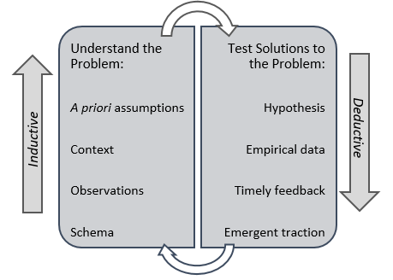
Phased Emergent Analysis Model
The exploration phase uses an inductive epistemic orientation for understanding the problem, meaning that we start with our own a priori assumptions (i.e., current beliefs and schema), and begin our process of understanding the problem and the contextual variables that surround it. This is typically done through: observation of the problem, reviews of academic literature, and discussions with those closest to the problem itself. This is an immersive and distinctively qualitative phase. As our schema deepens, causal drivers of problems will begin to emerge. Identification of these drivers allows us to separate symptoms from causes.
Once an initial sense of the problem is developed, we quickly shift into a deductive phase, meaning that we be begin hypothesizing and testing solutions (i.e., interventions) to the identified drivers. We are not attempting to address the entire problem, just one or two causal drivers at a time. In this way, we can begin gathering empirical data to see which interventions work and which fall short. This is typically a quantitativephase. The timely feedback gained from short intervention testing cycles allows us to gain initial traction on the problem, incrementally working to better analyze, understand, and ultimately address it. Understanding deepens with engagement. Working within the medium of the problem leads to a more robust understanding of it.

A Closer Look at the Testing Phase
We’ve identified a problem and our understanding of it is deepening. Members of our team have reviewed and synthesized relevant academic literature; others have interviewed the people who are most familiar with the problem, and have summarized their findings; and others have conducted observations, and written-up their results. All this information has been shared, a handful of candidate causal drivers have been identified, and we’ve updated our priors. Now it’s time to create and test some solutions using our updated schema. This can be done using a variation of the PDSA sequence tailored for short-cycle improvement studies (Figure 2).

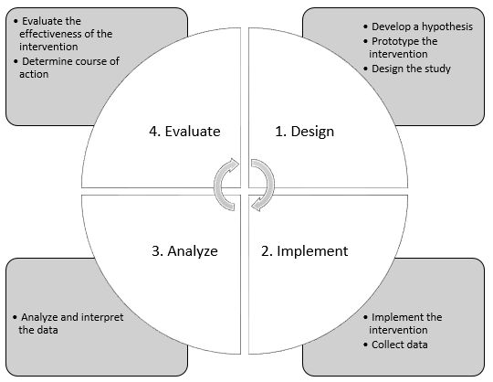
Short-cycle Improvement Study
Testing begins with a design step that involves choosing one of the candidate drivers and hypothesizing how it could be addressed. For example,
“If medical personnel wash their hands for no less than 30 seconds with provided antibacterial soap and refrain from direct physical contact with other people and surfaces between patient visits, then measured nosocomial infection rates will decrease by 40%.”
This hypothesis defines the intervention and communicates an expected impact on infection rates. The intervention is simple to implement, scalable, and minimally designed. We want to keep it simple. Once this is established, we can develop the study protocols, time frame, and data needed to assess the impact of the intervention. These protocols should be easy to implement, and the study time frame should be < 90 days. Collected data should require minimal effort to collect, be easy to analyze and should facilitate objective interpretation.
The next two steps involve implementing the intervention, collecting our data, and then analyzing and interpreting the data. The final step is to evaluate the efficacy of the intervention and determine how to proceed. If we determine the intervention to be successful, it can be integrated into regular practice or policy. If we determine it to be unsuccessful or partially successful, it can be abandoned or revised for further study. Lessons learned from the testing cycle can now feed back into our understanding of the problem, priors can be updated, and a new round of study can be started with another driver or a revised version of the current driver. Through this recursive process, we begin to peel away layers of the problem, individually addressing each while developing a deeper understanding of it.

Final Thoughts
The short-cycle improvement study works most effectively for applied research in scenarios that require contextually sensitive responses to complex problems. It can be used for: (a) initial development and testing of interventions, (b) testing proven interventions to assess their effectiveness in a different context, or (c) to address problems with a minimal investment of resources.
Developing a rapid yet sustainable tempo for operational improvement is a key function of high performing organizations. The short in short-cycle cannot be overemphasized. The power of this approach is its parsimony. Large scale longitudinal studies have their place, but short-cycle studies provide a method for analyzing and addressing problems that cannot wait for the the findings of long term studies. Two institutions - the Carnegie Foundation for the Advancement of Teachingand the Institute for Healthcare Improvement - have pioneered the development and application of these methods. Each deserves recognition for those efforts.

Key Ideas
- Let the phase of the study inform your epistemic orientation. Exploration phase: inductive. Testing phase: deductive.
- Context is critical. Solutions to most things within the social sciences are contextually contingent.
- Understanding deepens with engagement. Working within the medium of the problem leads to a more robust understanding of it.
- Make sure you are addressing the causal drivers of the problem rather than just the symptoms.
- Address one causal driver at a time rather than attempting to fix the entire problem (see Idea #2).

